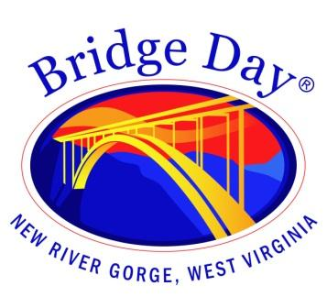

Bridge Day Commission

Fayetteville Town Hall | August 16, 2023 at 1:30 pm

Meeting Agenda
66 Days

Call to order

- Minutes from July 19, 2023 - review and approval

- Old Business
  - Review and approve recommendation for Hills to Hills Shuttle to run shuttle service during Bridge Day

- New Business
  - Emergency Services advisory position
  - Review of Event Timeline

- Report from BDC representatives

- Adjourn

