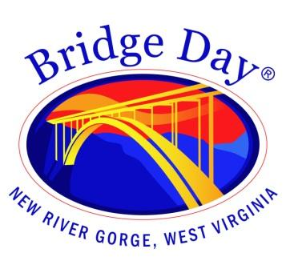

Bridge Day Commission

Fayetteville Town Hall | July 19, 2023 at 1:30 pm

Meeting Agenda

Call to order

- Minutes from June 21, 2023 - review and approval

- Old Business
  - Review and approve code of conduct for advisory representatives

- New Business
  - Bridge Day Car Show

- Report from BDC representatives

- Adjourn

