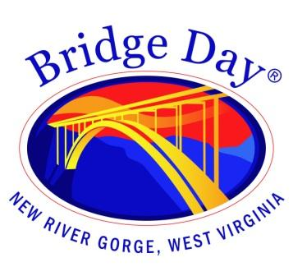

Bridge Day Commission

Fayetteville Town Hall | October 11, 2023 at 1:30 pm

Meeting Agenda
10 Days

Call to order

- Minutes from October 4, 2023 - review and approval

- Weather briefing with Chad Merrill, WOAY-TV

- Report from BDC representatives

- Round the room

- Next meeting date - October 18, 2023

- Adjourn

