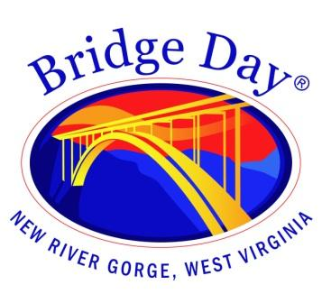

Bridge Day Commission

Fayette County Courthouse Commission Chambers

October 23, 2023 at 1:30 pm

Meeting Agenda

Call to order

- Review of event
  - WVSP
  - FCSD
  - County Commission
  - WVDOH
  - Town of Fayetteville
  - Chamber of Commerce

  - BASE
  - Rappel
  - NPS
  - Vendor/Community
  - Emergency Services
  - Regional Tourism

  - DDI River Rescue
  - Fayetteville Fire Dept
  - Fayetteville PD
  - Health Department
  - Board of Education
  - WVDOT
  - Whitewater Photo
  - Active SWV
  - Taste of Bridge Day
  - Chili Cook Off
  - All others

- Next meeting date

- Adjourn

