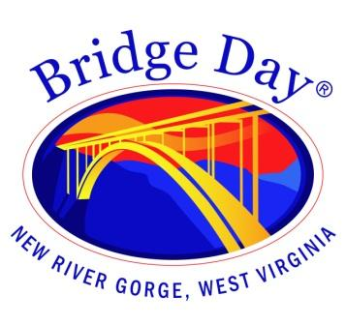

Bridge Day Commission

Fayetteville Town Hall | October 4, 2023 at 1:30 pm

Meeting Agenda
17 Days

Call to order

- Minutes from September 27, 2023 - review and approval

- Old Business

- New Business

- Report from BDC representatives

- Round the room

- Next meeting date - October 11, 2023

- Adjourn

