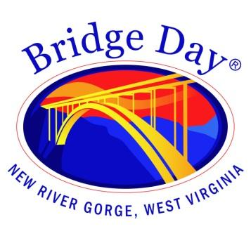

Bridge Day Commission

Fayetteville Town Hall | September 27, 2023 at 1:30 pm

Meeting Agenda
24 Days

Call to order

- Minutes from September 20, 2023 - review and approval

- Old Business
  - Vehicle permits
  - Day of event contact phone numbers

- New Business
  - Follow up on lunch delivery plan

- Report from BDC representatives

- Round the room

- Next meeting date - October 4, 2023

- Adjourn

